Is Calycellina ulmariae a solution?
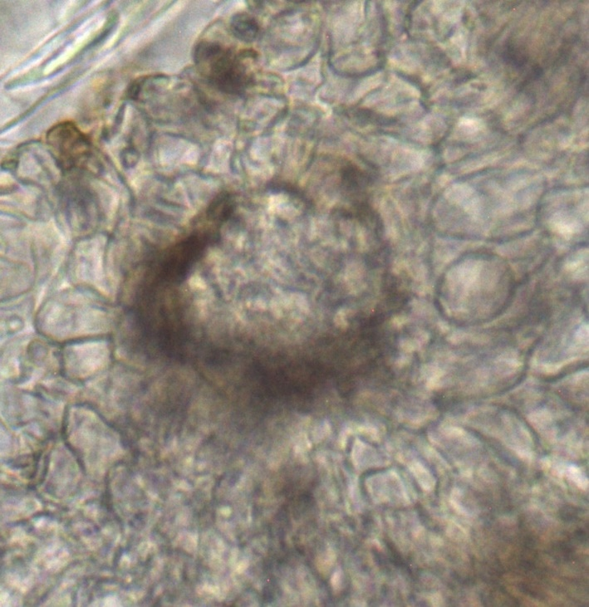
Brown apical ring clearly visible, as well as the light refracting vacuoles of the ectal excipulum

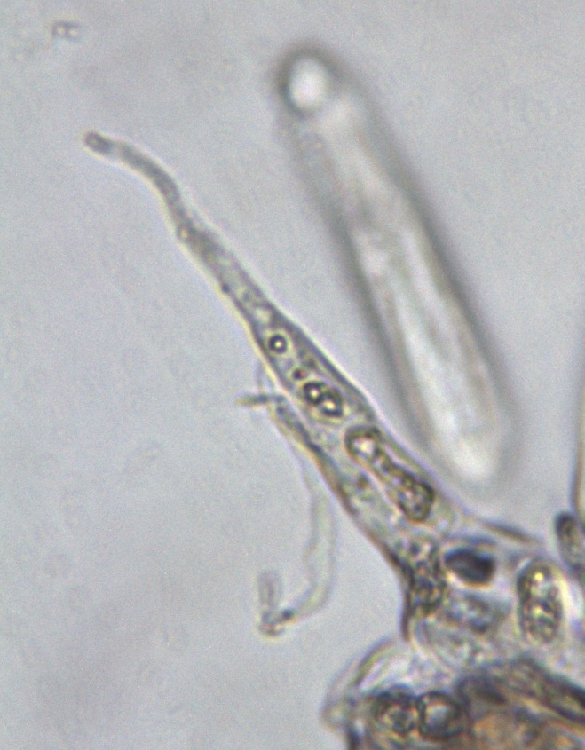
Hairs apically round and basal with light-breaking vacuoles
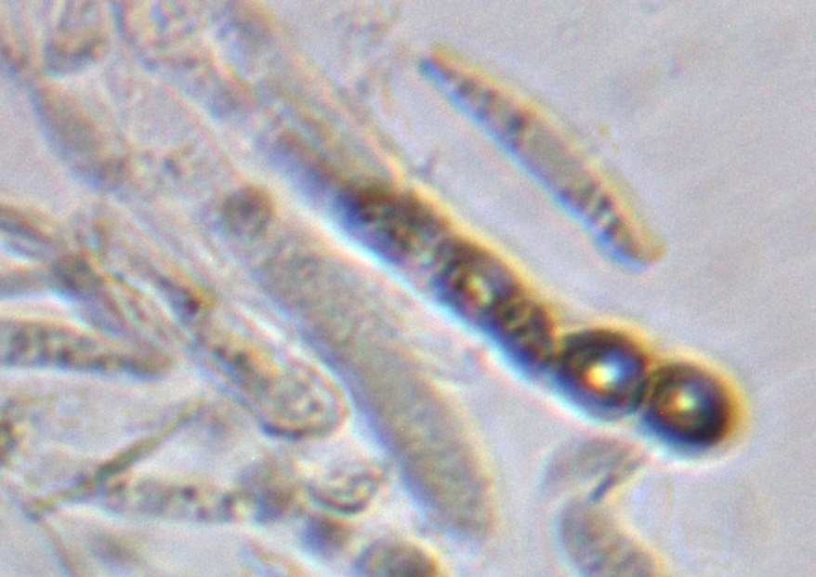
Paraphyses cylindrical with large light refracting vacuoles

The first picture shows part of the excipulum but I find it difficult to determine the textura.

