Cosmospora aurantiicola (Berk & Broome) Rossman & Samuels

Anamorph: Fusarium larvarum Fuckel

Description: Ascomata superficial, solitary or in group of 2-5 on leaves of Frullania dilatata, some on bark, pyriform, 270-320 µm high, 180-220 µm diam, red-orange to red, collapsing lateraly or not collapsing, 3%KOH+ deep purple, yellow in lactic acid. Cells at surface forming textura epidermoidea. Papilla broadly conical , 70-80 µm diam 70-100 µm high, made of clavate hyphal elements thick-walled, ostiolar canal periphysate.
Lateral wall in vertical section 25-30 µm thick (40-50µm according to C. Booth 1971) made of two regions: outer region 15-20 µm thick, made of globose to ellipsoid cells 5-10 x 4-6 µm with 2-2,5 µm thick-wall; inner region 6-10 µm thick made of thin-walled, elongate, hyaline cells 10-15 x 3-5µm.
Asci cylindrical, to narrowly clavate, 80-95 x 7-9 µm, stipitate, apex rounded without ring, 8-spored, ascospores obliquely uniseriate or apically biseriate.
Ascospores widely fusiform to ellipsoid, (10-) 12-14 (-16) x 5-5,5 µm, 1-septate, constricted at the septum, hyaline becoming pale brown and finely verrucose when mature.

Cultural characteristics:2,5-3cm diam after 25 d at 25°C on Difco PDA containing 5mg/L Streptomycin, orange- salmon.

Specimen examined:
France, Montgeorge, Doubs, MEN 3424A, 25 Feb. 2008 on Frullania dilatata, collected by Gilbert Moyne, deposited at Faculté de Pharmacie de Lille, France (LIP) CLL7157, culture deposited at CBS?????? I’m waiting for accession number

Additional specimens examined: France, Haute-Marne, Pressigny, Val Morel, 28 Oct. 2008 on Frullania dilatata, collected by A. Gardiennet.

Notes: This species is not obviously fongicolous but associated with scale insects and fits well to the genus Cosmospora Rabenh. by its ascomatal wall structure, pale brown ascospores when mature and its anamorph Fusarium but it is unusual in its habit on Hepatic, according to Rossman (1999) the genus Cosmospora is usually fongicolous. No species of Cosmospora has previously been described on Frullania. This species is new for France.

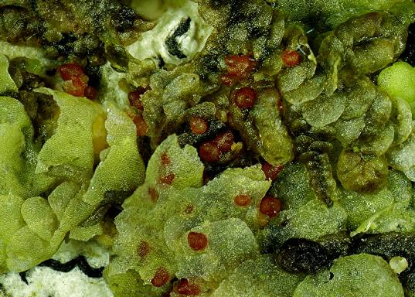

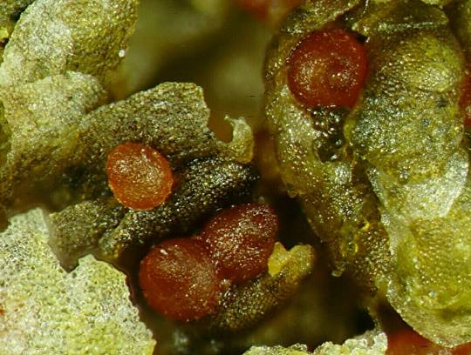

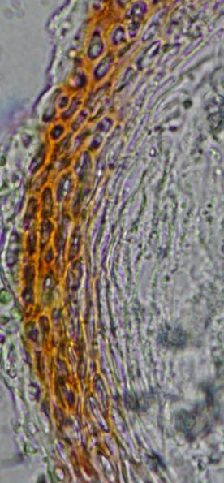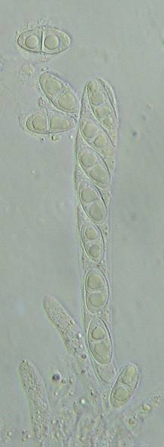

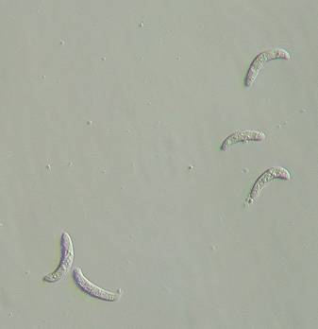
Conidia of Fusarium in culture

