KEY TO ASCOCORYNE

H.O. Baral, Oct. 2000

Species of Ascocoryne are often believed to be difficult to identify. However, with living fresh specimens the c. 4 European taxa are rather easily distinguished.

Highly constant among the many studied fresh collections proved the lipid pattern (multiguttulate versus 2(-4) very large and several small LBs) in the mature (aseptate) ascospores which readily allows to recognize the two sections (cylichnium vs. sarcoides). The immature spores, however, contain many small LBs (multiguttulate) in both sections. Due to strong coalescence in dead material, this striking difference is exclusively constant in living material and should especially be examined from spores within living asci. The two sections can further be distinguished by the consistency of the apothecia (distribution and abundance of gel), the presence of crystals, by the presence of conidiomata, and by the type of spore germination. Only the latter two features have so far been used in the literature. The genus is somewhat variable concerning paraphysis shape and content, spore size and shape, and ascus size. No differences between the species could be found in the type of apical apparatus.

Spore germination: Ascospores are always aseptate and with high lipid content within the living mature asci. Both formation of septa and germination (including budding) occur only in overmature spores. Overmature spores are those which have undergone post-maturation either outside the asci after active discharge, or within dead asci which have not managed spore discharge. Thus conidia are never forcibly ejected and cannot be termed ascoconidia as is frequently done in this genus, and apothecia in optimal developmental state may completely be devoid of septate spores and conidia. In order to obtain germinating spores and conidia in great abundance, apothecia are kept in a moist box for some days or weeks (at 10-20°).

In contrast to this, overmature material of A. sarcoides may contain some or many living asci with overmature spores (with 1-septum and c. 5-15 µm long germ tubes, partly as conidia in chains). This situation is clearly unphysiological, and effective spore discharge seems most unlikely with such germ tubes.

The purplish-violet pigment stains the medium distinctly blood-red when adding KOH (cylichnium).

Ascocroyne-Serpula-Sukzessionsphase (Winterhoff 2001: 143) wohl auf cylichnium bezogen.

KEY

1. Living mature ascospores constantly with 2(-4) large, symmetrically arranged LBs (2-)2.5-4(-4.7) µm diam. among many small ones; overmature with (0-)1-3 septa, producing either normal germ tubes or moniliform chains of limoniform to terminally ± globose conidia that remain cohering (blastocatenate), [solitaria not??!!]; often associated with sessile or clavate-stipitate to cerebriform conidiomata; whole medulla strongly gelatinized (apothecia therefore highly gelatinous-elastic), composed of very narrow hyphae (*1-4(-6) µm wide), intercellular space very wide, filled with gel, subhymenium non-gelatinized; complete apothecium without crystals
Sectio Sarcoides

1. Living mature ascospores constantly multiguttulate (mixture of many small and medium-sized LBs, the latter 1-2(-2.7) µm diam.; overmature with (1-)3-5(-6)-septa, producing in abundance subglobose(-ellipsoid) phialoconidia on extremely short phialides (0.2-1.2 x 0.6 µm) directly on the ascospore, sometimes also on germ tubes, conidia soon detaching, never cohering; never producing conidiomata; medulla non-gelatinized or at best outer layer (c. 100-200 µm) medium gelatinized (apothecia therefore only slightly gelatinous), composed of rather thick hyphae (*?8-12 µm wide) with rather narrow intercellular space, subhymenium gelatinized or ?not, with abundant crystals and druses throughout the medulla Sectio Cylichnium

 | sectio sarcoides | sectio cylichnium
Conidia on ascospores | conidia forming chains of firmly cohering cells, conidia produced terminally (blastoconidiate*) | conidia not forming chains, conidia produced directly on the ascospore ends
LBs in ascospores | two large mixed with many small | purely many small
Crystals in medulla | absent | present

*fide Kendrick & Carmichael (?1973)

Sectio Sarcoides

1. Hymenium light greyish-reddish-brown with carneo-violet tint, (1-)2-6(-12) mm diam., with rather long, conical stalk; spores *(11-)14-17(-19) x 4.2-4.5(-4.8) µm, with 2(-4) large LBs 1.5-2.5(-3) µm diam., overmature 0-1-septate, germ tubes not moniliform; asci IKI BB; apices of paraphyses cylindrical to medium clavate, */(1.5-) 2.5-4.5 µm, upper 8-30 µm medium refractive multiguttulate, conidiomata (Coryne albida) stipitate-capitate, c. 1-3 x .... mm, singly but gregarious, pale flesh-coloured, cells of conidiophore medium to strongly inflated (bulb/onion-shaped to globose), containing a refractive KOH-soluble crystal, conidia *3-3.5 x 1-1.2 µm, slightly to medium allantoid, 1 minute LB in each end; medullary hyphae sometimes multiguttulate; on wood of stems and branches of Fagus, Quercus, Betula, Carpinus, on cones of Pinus (only anamorph), slightly to strongly rotten, in shady, humid woods, e.g. in creeks A. solitaria

1. Hymenium deep red-purple-violet, 1-30 mm diam., sessile to rather long-stalked, ascospores overmature mainly 1-3-septate, germ tubes strongly moniliform (chains of cohering conidia), conidiomata absent (?or cushion-shaped) or clavate or flabelliform-cerebriform, conidiophores narrowly fusoid to cylindrical, without plasmatic crystals 1.5

1.5 Medulla with large globose cells, ascospores *(11.4-)13.5-18.6 x 4.8-6 µm, ends obtuse, conidia on spores *3.2-6 x 2.1-3.4 µm, apoth. 18-44 mm diam., sessile, never with associated conidiomata, on Alnus, Fagus, Fraxinus, Croatia
A. cerebriformis Matocec sp. nov.
1.5 Medulla without globose cells 2

2. Ascospores with obtuse to subacute ends, *(14-)17-26(-29) x (4.4-)4.7-5.5(-6) µm, terminal conidia on germ tubes globose, *2.8-3.5(-4.3) µm wide; paraphyses strongly to very strongly capitate, never guttulate, apothecia 1-10 mm diam., 1-5 mm thick, cushion-shaped to obconical, broadly sessile, margin often ± appressed to substrate, sometimes associated with small conidiomata (0.5-1 mm high, irregularly cerebriform, pale rosaceous-purpuraceous, non-gelatinous) (phialides *10-15/1.8 µm, conidia *4-4.5 x 1 µm, medium allantoid); on very rotten wood or bark of fallen branches or trunks of Carpinus, Fraxinus, Fagus, Alnus, Acer, Betula, shady woods, creeks or Alneta
A. inflata (formerly disciformis) sp. nov.
HB 3121, 6772, 6788a, 6810, 6838, 7059, 7598

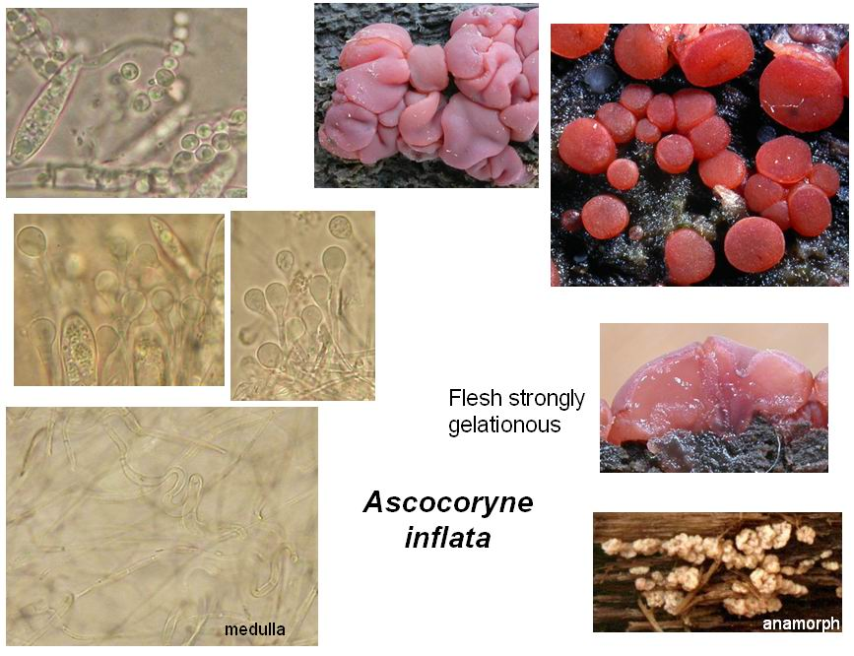
Medulla of highly gelatinized t. intricata, ascospores producing globose conidia in chains

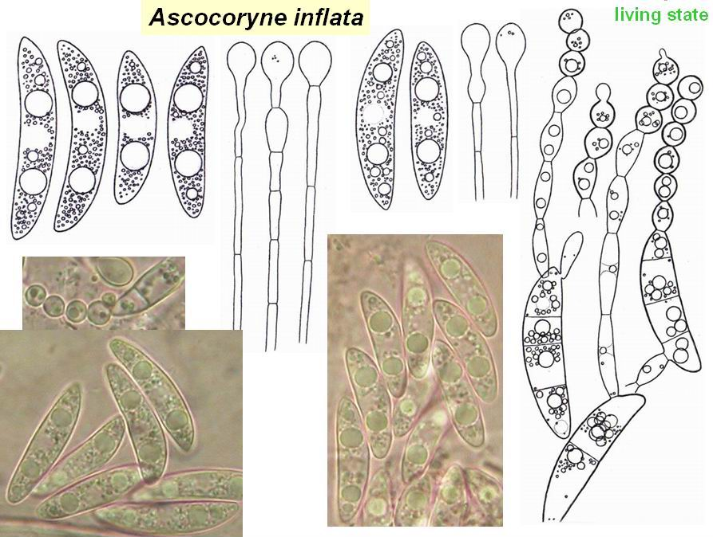

2. Ascospores with constantly ± obtuse ends, *(11-)14-21(-24)((-26)) x (3.8-)4.4-5.2(-5.5) µm, terminal conidia on germ tubes lemon-shaped, *2.2-2.5(-2.8) µm wide; paraphyses slightly to medium (eventually also strongly) inflated, young strongly refractive multiguttulate, later with a few large VBs; apothecia 3-30 mm diam., c. 4-13 mm thick, obconical-turbinate, with a ± conspicuous stalk (not rarely higher than wide), margin never appressed to substrate, nearly always associated with rather large conidiomata (stipitate, clavate to flabelliform-cerebriform without delimited head, c. (2.5-)5-15 x 1-5(-15) mm, often fasciculate, deep purplish-violet, phialides *9-15(-20) x 1.3-1.5 µm, conidia *(2.8-)3.3-5.5 x 1-1.4 µm, slightly (to medium) allantoid, 1 minute LB (or 0.6-0.8 µm) near each end, some with small polar appendage so that conidia at first loosely cohere in chains); on wood or bark of branches, trunks and stumps of Fagus, Quercus, Alnus, Prunus, Tilia, Carpinus, Castanea, Acer, Pinus, Larix (never on Picea?), often undecayed or only slightly rotten (rarely strongly rotten), sometimes in dense mats of Hypnum, in creeks or shady woods, ?slightly xerotolerant A. sarcoides

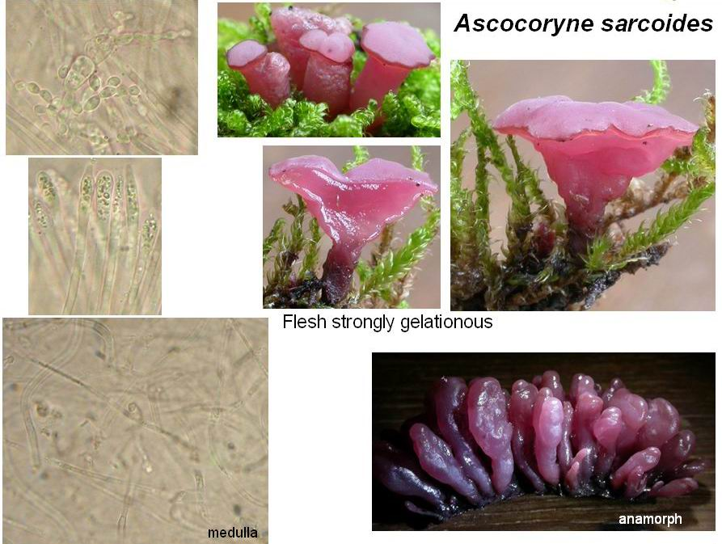
Medulla of highly gelatinized t. intricata, ascospores producing lemon-shaped conidia in chains

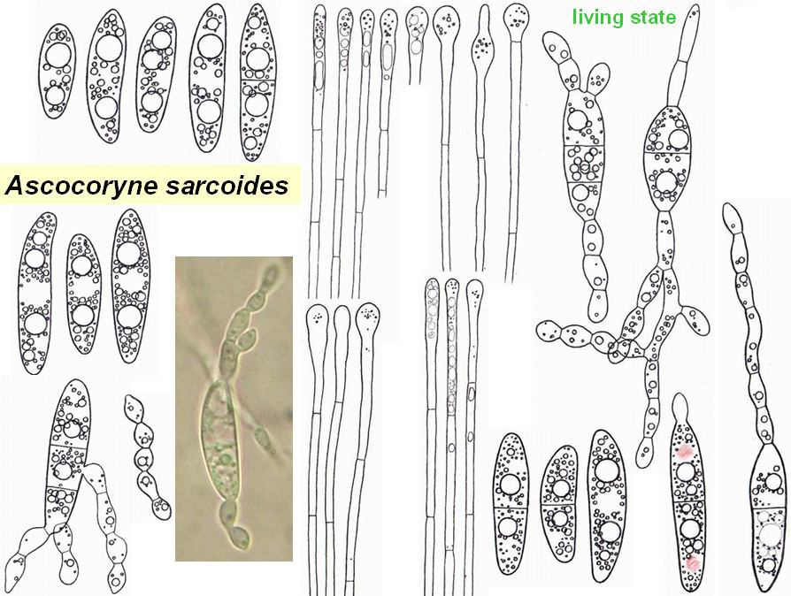

Sectio cylichnium

1. Spores *16-20(-22) x 4.4-5 µm, subfusoid, 2 LBs 1.8-2.3 µm & 2 LBs 1-1.8 µm among ± many small ones (intermediate sizes frequent), overmature (1-)3-septate, conidia on spores *2-3 x 2-2.4 µm, with 1 large LB, sometimes also on long germ tubes (rarley as chains!); medullary hyphae below hymenium †2-4.5 µm wide, in distinct gel, no crystals; paraphyses around ascogenous hyphae non-gelatinized???; asci *175-222 x 9.3-10.5 µm, arising from croziers; apices of paraphyses cylindrical, */2-2.4 µm, with elongate VBs; apothecia 2-5.5 mm diam.; conidiomata ?slimy mass near apothecia, phialides *13-15 x 1.8-2.5 µm, conidia *2.5-3 x 1.3 µm, ±straight, on wood of branch of Picea, very rotten A. conifericola sp. nov.?
HB 4248 (Nürtingen)

1. Spores (19-)22-30(-35) x (4.2-)5-6(-7) µm, always ±fusoid, overmature 3- or 4-5(-6)-septate, inner medulla (500-1000 µm) of rather dense texture of wide hyphae (*5-12 (-17.5) µm) embedded in little non-refractive gel, pale purpuraceous, nearly always with abundant crystals and druses (hyaline or pupuraceous, mainly below subhymenium), paraphyses around ascogenous hyphae mostly gelatinized, asci *10.5-14.6 µm wide 2

2. Spores (20-)24-29(-33) x (4.2-)5.2-5.6 µm, large LBs in spores 1-2(-2.7) µm diam., spores overmature mainly 3-, also 4-5-septate, paraphyses slightly clavate, with ± large 1-2refr. VBs, asci *208-230 x 11.3-12.3 µm, with croziers, on coniferous wood, e.g. in creeks, in cluture only subglobose conidia A. "Evi"

2. Spores of same size, large LBs in ascospores 1-1.5 (-1.8) µm diam., overmature (3-4-)5(-6)-septate, in culture both allantoid and subglobose conidia produced 3

3. Asci arising from simple septa (always with basal downward protuberance); conidia 2.5-3 x 1.9-2.3 µm, with 1 large and/or several ±small LBs; paraphyses slightly to medium (-strongly) capitate/clavate, upper cell *33-60 x 2.8-4 or 4-5.3 µm, upper 6-27 µm (2-3refractive) multiguttulate; SCBs?; apothecia 1.5-20 mm diam., 1-5mm tall; on wood of branches of Alnus, Fagus, Picea, ?Carpinus, colline & montane, mostly in humid woods, e.g. creeks A. cylichnium var. deuncinata var. nov.
HB 4253, 6255a, 4340, 6793, 6791, 6800b, 6839.

3. Asci arising from croziers; conidia *(1.9-)2.3-3(-4.5) x (1.5-)1.7-2.2(-2.4) µm, either 4-8 small LBs or 1 large; paraphyses not or only slightly clavate, upper cell 21-35 x 1.7-3.5 µm, upper 8-24 µm 1-2refr. multiguttulate; medullary hyphoid cells with large, refractive, globose or sometimes elongate SCBs (2-5 µm) ?near margin; apothecia 4-22 mm diam.; on wood of stems, stumps or branches of Fagus, Salix, Carpinus, Fraxinus, Quercus, Populus, also not rarely on Abies, Picea, Pinus, little to strongly rotten, in shady humid woods, especially in creeks A. cylichnium var. cylichnium

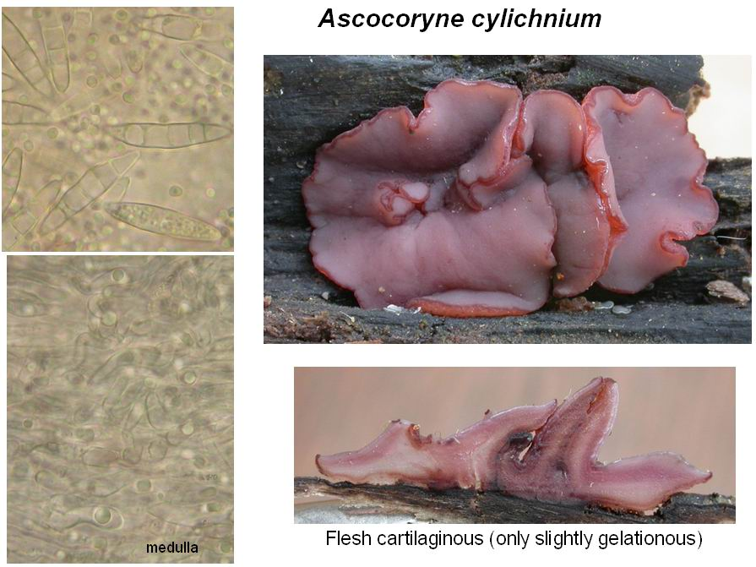
Medulla of little gelatinized t. porrecta, cells containing large refractive globose SCBs. Crystald and druses of calcium oxalate present in medulla. Ascospores producing ovoid-subglobose conidia that do not remain connected in chains.

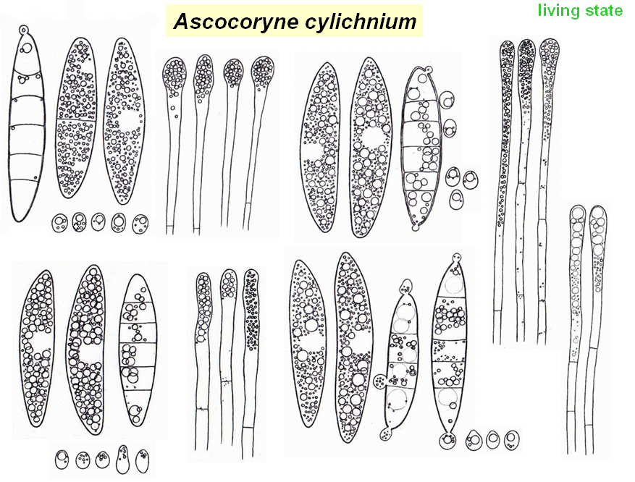
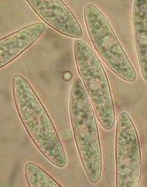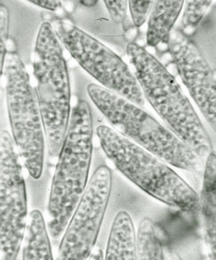

Table of characters

Expl.: crz (croziers); IKI (Lugol); LB (large lipid bodies): 2 = 2 large LBs, m = multiguttulate; grm (germination): hy = normal germ tubes, mo = moniliform germ tubes with globose conidia in terminal chains, co = single subglobose conidia; med (medulla): gel = whole medulla highly gelatinous, of narrow hyphae, apothecia highly elastic, th = main upper part little gelatinous, of thick hyphae, apothecia rather tough, only slightly elastic; cry (oxalate crystals in medulla); ans (anamorph shape): sl = slimy mass, cr = cerebriform-cushion-shaped, non-gelatinous, cl = clavate to flabelliform, st = stipitate with globose head; aps (apothecial shape): st = +/- stalked, us = unstalked, wholly appressed to substratew; tel (teleomorph): f = frequent, m = medium frequent, r = rare; an (anamorph): dto.; par (paraphyses): apex 1 = slightly inflated, 3 = strongly inflated (capitate); ht (host): c = coniferous, d = deciduous; og (organ): b = bark, w = wood, c = cones.
 | asci (*) | crz | IKI | ascospores (*) | LB | septa | grm | med | cry | ans | aps | tel | an | par | ht | og
inflat | 146-185(190?) x (10.5)11.5-13 | + | BB | (14)17-27(29) 4.4-6µm | 2 | 1-3 | mo | gel | - | cr | us | f | r | 3-4 | d | wb
sarc | (120)140-180(200) 9.3-13(14.5) | + | RB | (11.5)14-21(26) (3.8)4.2-(5.3) | 2 | 1-3 | mo | gel | - | cl | st | m | f | 0-3 | cd | wb
sol | 115-155 9.5-11 | + | BB | (11)14-17(19) 4.1-4.8µm, | 2 | 1 | hy | gel | - | st | st | r | f | 1 | cd | wc
conif | 175-222 9.3-10.5 | + | BB | 16-20(22 4.4-5 | m | (1)3 | co | gel | - | sl | st | f | ? | 1 | c | w
Evi | 208-230 11.3-12.3 | + | BB | (20)24-29(33) (4.2)5.2-5.6 | m | 3(5) | co | th | + | - | st | r | - | 1 | c | w
cyli | 175-275 10.5-13.5 | + | BB | (20)22-28(30) (4.7)5-6(6.4) | m | (3)5 | co | th | + | - | st | f | - | 1 | cd | w
deunc | 160-265 10.5-14.6 | - | BB | 22-30 5-6.3(7) | m | (3)5(6) | co | th | + | - | st | f | - | 1 | cd | w

