Durella sp? JF 07032

Ariège, Rimont, Saurine, 31/03/07, on bark a dead stem of Frangula alnus.

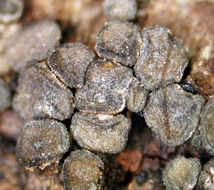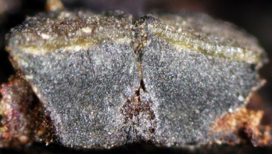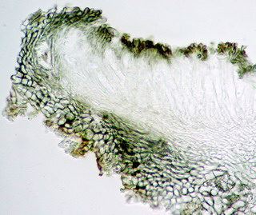
Ascomata erumpent in clusters, turbinate, 0.6-0.7 mm high, disc 0.75-1.25 mm diam, olivaceous grey turning dark
grey upon drying, margin darker but covered with a white pruina. Hymenium olivaceous seated on a thin, paler layer.
No pigments released in KOH.
Basal part very thick, blackish, jelly-like, textura angularis to prismatica.
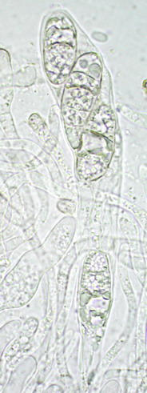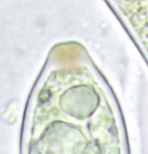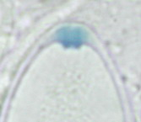Asci unitunicate, clavate, short-stipitate, 95-110 µm long x 16-17 µm broad, 4-spored, with a flattened to obconical apical apparatus, dirty brown in IKI, turning blue after KOH pre-treatment.
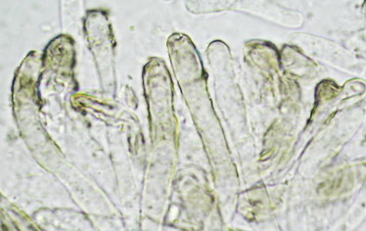Paraphyses cylindrical, swollen at the tips, hardly longer than asci, 2.5-3.5 µm broad, septate, ramified, hyaline, with tips encrusted with olivaceous brown substance not dissolving in 3% KOH, forming an epithecium above the hymenium.
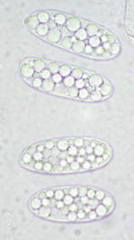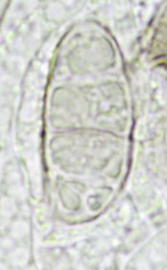Ascospores 22-25 x 8.5-9.5,µm, ellipsoid with broadly rounded ends, first hyaline and filled with oily globules 2.5-3.5 µm diam, turning yellowish and 3-septate, septa thin and often irregularly spaced, hardly constricted at septa. Wall smooth, without mucilaginous sheath.

Comments: I suggest Durella but without conviction because I am not familiar with these fungi.

